**LEBANESE AMERICAN UNIVERSITY**

**USAID – HIGHER EDUCATION SCHOLARSHIP PROGRAM**

**HES - Volunteering Program Verification Form**

This form is to be used to document volunteering hours. If a student volunteers for multiple organizations, a separate form must be used for each organization. **This form must be turned in by the 28th of each month, the latest.**

I certify that the scholar Charbel Farhat completed a total of 5 hours of service at Life Sculptor.

The hours were completed hours as per the below:

Hours # 0 (date) _30/09 – 5/10_ (initials of supervisor) __A.K.___

Hours # 0 (date) _7/10 – 11/10_ (initials of supervisor) __A.K.___

Hours # 5 date) _14/10 – 18/10 (initials of supervisor) __A.K.___

Hours # 0 date) _21/10 -25/10 (initials of supervisor) __A.K.___

Brief description of the activities the scholar performed or participated in:

The task involved conducting research on "The Impact of Social Media Influencers on Consumer Behavior." Following the research, a PowerPoint presentation was prepared to summarize the findings effectively. Additionally, twelve tips were compiled to enhance social media strategies for brands looking to leverage influencers in their marketing efforts.

Written feedback about the scholar’s performance:

Charbel shows excellent research skills and the ability to synthesize complex information into clear and actionable insights. His critical thinking and strategic mindset are evident in his approach to understanding broader trends and applying them practically. Charbel’s strong communication skills enable him to present ideas effectively, showcasing his talent for engagement and influence in digital contexts.

Please rate the overall performance of the scholar at your organization:

|  |  |  |  |
| --- | --- | --- | --- |
|  | Mastery (5) | Proficient (3) | Emerging (1) |
| **Problem solver** | X |  |  |
| **Engaged & Committed** | X |  |  |
| **Open-minded & multicultural** | X |  |  |

Signature

& stamp

__________________________

_

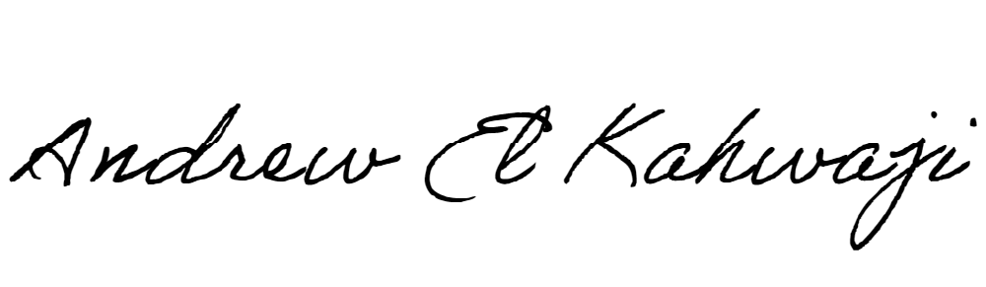

Printed Name _Andrew El Kahwaji_

Date __26/10/2024___

Email __andrew.lifesculptor.coo@gmail.com __

Phone __+961 71 914 378__

**LEBANESE AMERICAN UNIVERSITY**

**USAID – HIGHER EDUCATION SCHOLARSHIP PROGRAM**

